Gross MOTORIdeas for Home Learning Activities
If you’re looking for gross motor activities for kids whilst staying at home, here are a few suggestions for home learning activities. Gross motor skills are important, they involve whole body movement and which involve large muscles of the body to perform every day functions such as running, walking jumping and even standing.
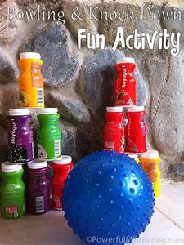
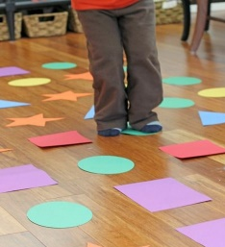
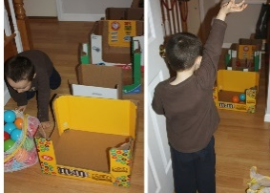

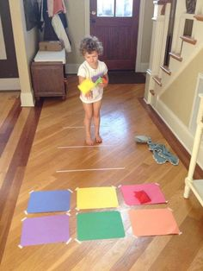

1 Cut out paper shapes, place shape on the floor, name the shape asking the child to stand on the correct shape, even better if you have coloured paper.
2 Collect, save empty bottles to assemble your very own skittle bowling.
3 Using coloured tape draw out shapes on a wooden or ceramic floor, children can then toss a bean bag on a named shape or can use each shape a target shot. If you don’t have a bean bag, you can make one by sealing dried beans, pebbles or sand into an envelope or sealed paper.
4 To play puddle hopscotch simply print or draw puddles, cut them out. Before placing them on the floor write a forfeit on each puddle for the child to do when lands on it. For example, hop on one leg, do a twist, touch your toes.
5 Have your child assemble empty boxes in a row and use them as a target for balls or bean bags to be thrown in them. The boxes can be decorates with paint, stickers or other materials of their choice.

