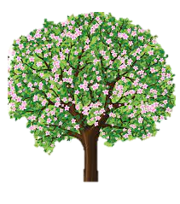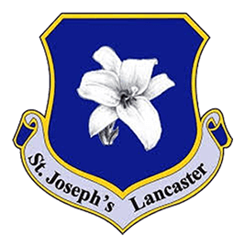

**Science**

Science will see us look at animals including humans. This means we will be looking inside the human body to the circulatory system and understanding the different parts and functions. From this, we will investigate how diet and exercise effects the body and look at the pulse and we will look at how drugs, alcohol and smoking effects the body and mind.

**Spring 1: Learning in Year 6**

**English**

We begin this year looking at classic narrative poetry. From this, we will be changing a poem to a story using speech and figurative language.

We will then move on to a non-fiction unit of information text linked to our topic on the Mayans.

**Supporting your child with their learning**

* Times tables support
* Telling the time and knowing durations
* Reading with your child – let them read to you and you read to them
* Using money

**What we are reading this half term:**

* Pig Heart Boy – Marjorie Blackman
* Why were Maya Games so Deadly?
* Lucy Grey – William Wordsworth
* The Highwayman – Alfred Noyes

**History / Geography**

We will be learning about the ancient civilisation of the Mayans; learning about the way they used to live, researching foods, building and religion. We will be using our geography skills to locate where they lived and the environment in which they built their civilisation.

**Computing**

Spring Term sees us looking at Online Safety in more detail and the unit ‘Quizzing’

**Maths**

We will be looking at measures, algebra, coordinates and start our SATS revision programme.

**PSHE**

With looking in to the effects of drugs, alcohol and smoking has on the body in Science, in our PSHE lessons be looking in to the law on these substances; at other names they have and why; why people take these substances and looking at situations young people have found themselves in regarding these substances and what is the right thing to do.

**Educational / Enrichment Visits**

We will be going to church and hopefully having a virtual Mayan talk – ‘Moment in Time.’

**P.E**

We will be looking at the area of Dance this half term.

**Art and DT**

In art we will be linking our drawing and painting skills to our history and looking into Mayan buildings, Gods and masks they had.

We will be looking into the foods the Maya people ate, linking to our previous DT project.

**R.E**

Year 6 will be looking into the experience of community as an essential and enjoyable part of life for people of every age and faith. We will also be linking, remembering, celebrating and responding to the experience of a wide variety of books and purpose for which they were written and the Bible as the story of God’s love told by the people of God.

**German**

This half term, we will be looking at the unit, ‘My School, My Subjects’ leaning words for everyday school items and the subject they learn.

**Music**

Our music will see us learn through the topic of ‘A new year carol.’

We will be singing and performing in our lessons.