**St. Joseph’s Catholic Primary School**

**Positive Relationships**

**Strategy**

|  |  |  |  |
| --- | --- | --- | --- |
| **Written by:** | **Date reviewed:** | **Approved by:** | **Date for next review:** |
| Miss Rachael Griffiths | September 2024 |  | September 2025 |

**Ready – Respectful – Safe**

Strategy Statement

St. Joseph’s is committed to creating an environment where exemplary behaviour is at the heart of productive learning. Everyone is expected to maintain the highest standards of personal conduct, to accept responsibility for their behaviour and encourage others to do the same. Our behaviour policy guides staff to teach self-discipline not blind compliance. It echoes our core values with a heavy emphasis on respectful behaviour, a partnership approach to managing poor conduct and dynamic interventions that support staff and learners.

Aims

Our school aims to:

* Provide a calm environment where learning is enjoyable and exciting.
* Care for and value everyone in the school and parish community as Jesus has taught us.
* Provide a safe and secure environment where everyone is respectful to each other.
* Encourage children to share the responsibility for their own education and behaviours.
* Promote good relations with others at school and in the community and always seek to be charitable global citizens.
* Help each individual to discover and develop new skills and abilities.
* Encourage children to be, self-disciplined, hardworking and caring.
* Provide challenge and support to achieve high standards.
* Celebrate the success, attainment and efforts of each child.

Our emphasis is on rewards to reinforce good behaviour, rather than on failures. We believe that rewards have a motivational role, helping children to see that good behaviour is valued.

Objectives

To meet these aims through our Positive Behaviour Strategy we have set the following objectives:

• All members of the school community will be involved in implementing this Positive Behaviour Strategy.

* In keeping with our TrackIt Light system, any behaviour that is deemed a serious incident will be logged on CPOMS via TrackIT Lights and a message sent home.
* The school will involve parents at an early stage if their child is persistently behaving in an unacceptable way or if a serious incident has occurred, either by a face-to-face meeting or conversation over the phone.
* Parents will be notified by Dojo Message, note in planner or phone call, of any red level behaviour.
* When a child has displayed red level behaviours, or the incident is deemed as a serious concern, parents will be invited into school to discuss their child’s behaviour with the Phase Leader or Headteacher.
* Parents, staff and children will behave towards each other with mutual respect, consideration and tolerance.

• We will celebrate positive behaviour with a robust and consistent system of rewards.

Classroom Management

Classroom management and teaching methods have an important influence on children's behaviour. The classroom environment gives clear messages to the children about the extent to which they and their efforts are valued. Relationships between staff and children, strategies for encouraging good behaviour, arrangements of furniture, access to resources and classroom displays all have a bearing on the way children behave. At the end of each day, the class room should be tidy, organised and ready for the next days learning.

Classrooms should be organised to develop independence and personal initiative. Furniture should be arranged to provide an environment conducive to on-task behaviour. Materials and resources should be arranged to aid accessibility and reduce uncertainty and disruption and be well labelled to promote independence. Displays should help develop self-esteem through demonstrating the value of every individual's contribution, and overall the classroom should provide a welcoming environment. Teachers should always be prepared for when the children enter the class.

Teaching methods should encourage enthusiasm and active participation for all. Lessons should aim to develop the skills, knowledge and understanding which will enable the children to work and play in co-operation with others. Praise should be used to encourage good behaviour as well as good work.

Strategies to promote good behaviour:

* staff are good role models of the school’s expectations;
* staff do not feel the need to raise their voices when addressing children
* class teachers establish class and school rules at the beginning of each academic year and remind pupils of these on a weekly basis;
* seize opportunities to highlight good behaviour;
* use praise to reward and encourage good behaviour and work;
* work is set to meet the interests, needs and abilities of individuals;
* Consider age, culture, disability or a child in trauma in determining expectations of behaviour; • consistent use of the school’s agreed rewards and consequences system.

The Curriculum and Learning

We believe that an appropriately structured curriculum and effective learning contribute to good behaviour. It follows that lessons should have clear intentions, understood by the children, and adapted to meet the needs of children of different abilities.

Marking and tracking can be used both as a supportive activity, providing feed-back to the children on their progress and achievements, and as a signal that the children's efforts are valued and that progress matters.

Values to live by

Positive behaviour is consistently reinforced. The school teaches the ‘Gospel Values’ where pupils learn the skills of self-awareness, self-regulation, motivation and empathy as well as social skills. Children are provided with consistent positive encouragement and recognition when they demonstrate positive behaviour, when their behaviour reflects the values and teachings of Jesus.

The Gospel Values are produced at the beginning of each academic year and are on display in each classroom. They are referred to frequently and should encourage the children to be positive in all they do and should help to create a happy environment for pupils to work in.

During celebration assembly, a V.I.P. certificate will be awarded to a child who has been noticed living out the Gospel Values throughout the week.

Incentives

We have whole school incentives and rewards to recognise and celebrate good behaviour, good work, helpfulness to peers and adults and where we see children living out the Gospel Values.

As a whole school, recognitions will be collected weekly and celebrated in Celebration Assembly. Those children who have achieved 4 or more weekly recognitions in a half-term will receive an end of half-treat in the first week back after the break. (Golden time)

Any children who have gone above and beyond in their work throughout the week will receive a Star of the Week Certificate in Celebration Assembly.

These rewards will be shared with parents/carers every week on the school newsletter.

Behaviour Management System

There is a Graduated Approach for Behaviour in place for the whole school.

See Appendix 1. Graduated Approach to Behaviour.

Consequences

Although rewards are central to the encouragement of good behaviour, realistically there is a need for consequence to register the disapproval of unacceptable behaviour and to protect the security and stability of the school community.

The use of consequences should be characterised by certain features: -

* Staff will consistently refer to the whole school Graduated Approach for Behaviour.
* It must be clear why the sanction is being applied.
* It must be made clear what changes in behaviour are required to avoid future consequence.
* Staff will use the language of choice to encourage children to make the right choice.
* It should be the behaviour rather than the person that is disciplined.

Immediate Red Level Behaviours – Immediate red level behaviours will be issued with a Report Card (see Appendix 2) for unprovoked violence, serious racist or homophobic incidents, physical violence towards an adult, deliberate destruction of school property, spitting at another person, continually swearing or swearing at a child or adult.

Deliberate behaviours that put themselves or others at risk.

In accordance with our inclusive practise, staff are to use their professional judgement when to accommodate behaviours associated with SEND and trauma.

Depending on the nature of the incident, a Report Card can be issued, behaviours may be logged with the Local Authority, police or for some severe incidents a fixed term exclusion can apply.

Exclusions will take into consideration the safety and safeguarding of each individual child.

Staff can refer to the Phase Leader or Headteacher to escalate a consequence straight to a yellow or red step.

Rewards

Class Dojo Points – 1 Ready Respectful Safe Dojo point is given for consistently showing good behaviours. When a child achieves 3 Ready Respectful Safe Class Dojos, they will be added to the class Recognition Board.

Class Dojo points can be awarded for:

* Personal achievements
* Good Attendance
* Participation in special events
* Outstanding behaviour
* Full engagement in learning
* Listening to the teacher and others
* Showing outstanding attitudes
* Trying hard with their work
* Contributing to discussions
* Contribution to the Catholic Life of the School

Children will be taught the importance of the Zones of Regulation during lessons throughout the year. Each classroom will have a Zones of Regulation area and staff will have the cards on their lanyards.

If a child is showing negative behaviours, they may be asked to use their Zones of Regulation area.

When a child feels like they are in Green Zone, they will be asked to re-join the class.

Zones of Regulation

.

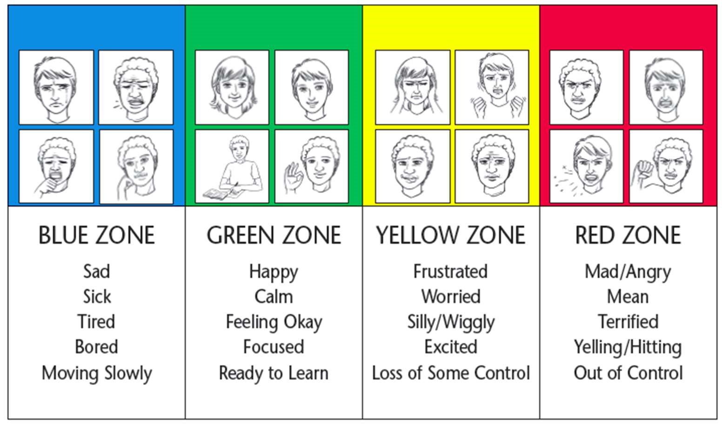

Lunchtime Supervision

At lunchtime, supervision is carried out by a team of lunchtime supervisors. Teachers will be informed by the lunchtime supervisors of good behaviour, kindness to others, helpfulness etc.

Behaviours which are deemed serious will be immediately referred to Phase Leader.

Communication and Parental Partnership

We give high priority to clear communication within the school and to a positive partnership with parents.

A positive partnership with parents is crucial to building trust and developing a common approach to behaviour expectations and strategies for dealing with problems.

The key professionals in this process of communication are the class teachers who have the initial responsibility for the child's welfare.

Early warning of concerns should be communicated to the safeguarding team and discussed at meetings so that strategies can be discussed and agreed before more formal steps are required.

The school will communicate policy and expectations to parents. Where behaviour is causing concern parents will be informed at an early stage, and given an opportunity to discuss the situation.

Parental support will be sought in devising a plan of action with the Pastoral Interventions Lead, SENCO, class teacher and the child to encourage positive behaviour. Targets will be set and reviewed every half term.

**Appendix 1.**

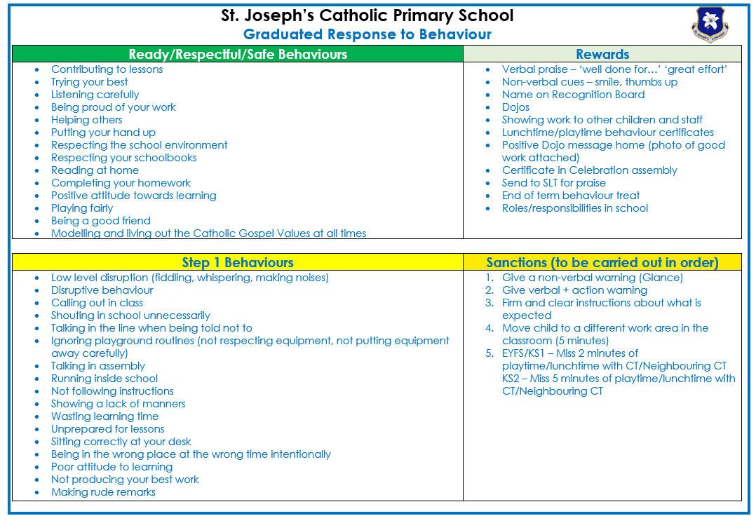

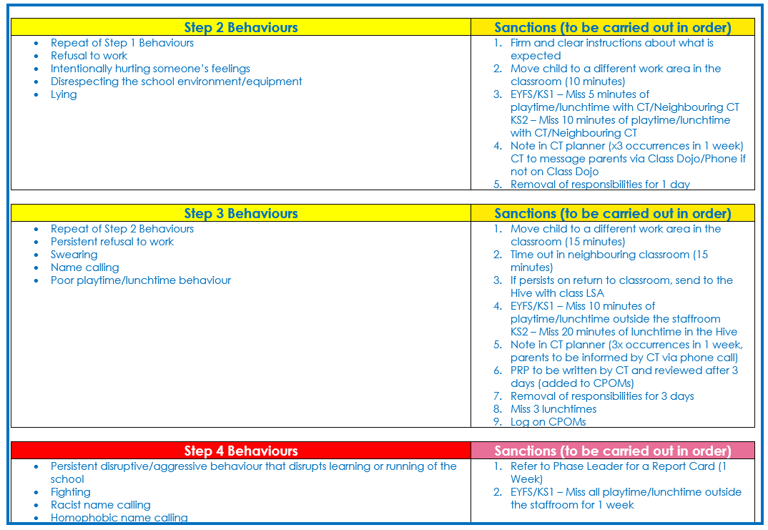

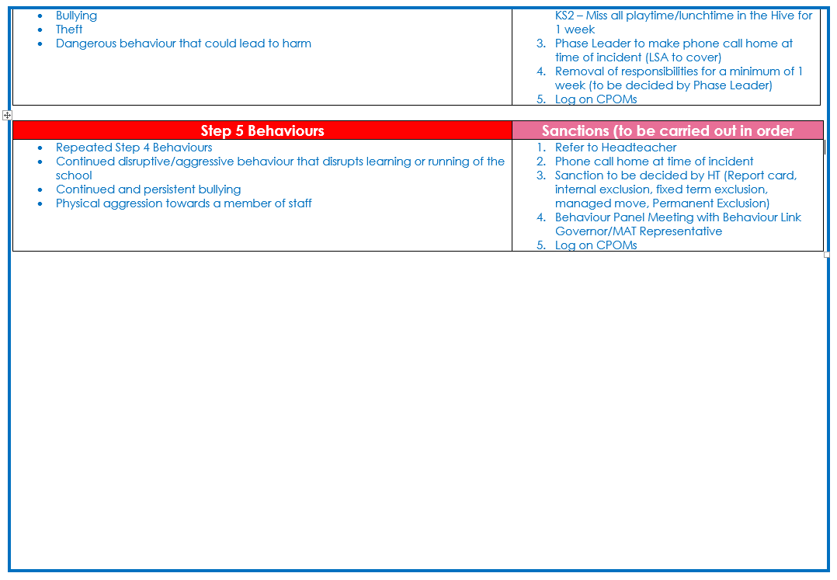

**Appendix 2.**

