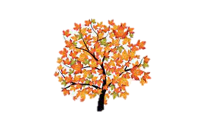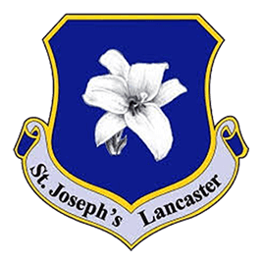

**English**

In our writing, we will be focussing on letter formation and using capital letters and full stops correctly when creating sentences.

In reading, we will be working on decoding words and blending them to read a range of fiction and non-fiction texts.

**Supporting your child with their learning**

* Reading as often as possible (at least 3 times per week).
* Support your child with completing their weekly homework tasks.

**Autumn 1: Learning in Year 1**

**Science**

In Science this half term, we will be learning all about seasonal changes and the weather, using our observational skills to make predictions and notice changes. We will link our knowledge to the four seasons and discuss how the lengths of day vary.

**What we are reading this half term:**

* Beegu by Alexis Deacon
* Where the Wild Things Are by Maurice Sendak

**Geography/History**

In Geography, we will identify, name and locate the world’s seven continents and five oceans before locating and recognising characteristics of the four countries and capital cities of the UK.

In History, we will be exploring changes within the living memory and discussing how things change over time.

**Maths**

We will begin our learning by developing our understanding of place value and numbers within 10. We will then move on to addition and subtraction.

**Computing**

We will begin the term looking at computing systems and networks before moving on to online safety whilst exploring purple Mash.

**Educational / Enrichment Visits**

This half term, we will be taking part in forest school, linking what we learn to our Science, DT and Geography knowledge.

**PSHE**

Our PSHE topic is ‘fun times’ where we will be learning all about special events and the way these are celebrated. We will also look at ways we can stay healthy and active.

**Art / DT**

In Art we will be focussing on using different drawing tools for simple mark making.

In DT we will be learning all about slider mechanisms, before building our own.

**P.E**

We will begin the year focussing on developing our fundamental movement skills through exciting individual and team games.

**R.E**

We will spend the half term learning all about how the world was created through the first creation story. Our focus is the Christian belief that all that exists comes from God. We will be creative when understanding where our world came from and link our learning to scripture and prayers.

**Music**

In music we will be coming together to develop our singing skills. We will then move on to controlling our voices through nursery rhymes.