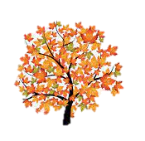
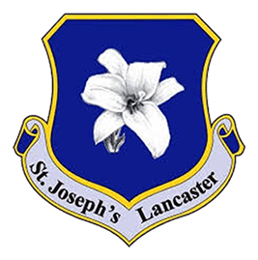
English
Our focus this half term in our writing is instructional texts, where we will write a set of instructions for growing a plant before following them to see how effective they were. We will then move onto descriptive writing, specifically stories with familiar settings and poetry towards the end of the term. In reading, we will be working on decoding words and blending them to read a range of fiction and non-fiction texts.

Supporting your child with their learning
- Reading as often as possible (at least 3 times per week).
- Support your child with completing their weekly homework tasks.

Autumn 2: Learning in Year 1
Science

Our Science topic for the remainder of the half term will be plants, including trees and animals, including humans. We will look into the different parts of a plant and the features of various animals.

What we are reading this half term:

- Beegu by Alexis Deacon
- Where the Wild Things Are by Maurice Sendak

Geography/History
In Geography, we will identify, name and locate the world’s seven continents and five oceans before locating and recognising characteristics of the four countries and capital cities of the UK.
In History, we will be exploring changes within the living memory and discussing how things change in our community over time.
Maths
We will continue to strengthen our understanding of number through our mastery approach whilst applying our knowledge to addition, subtraction and geometry topics before consolidating everything that we have learnt so far in Year 1.
Computing
We will begin the term looking at computing systems and networks before moving on to online safety whilst exploring purple Mash.

PSHE

We will focus on keeping safe and managing risk this half term, particularly feeling safe in familiar and unfamiliar situations.
Music
This half term’s focus for Music is untuned percussion where we will experiment with different instruments to introduce rhythm and pulse before representing sound pictorially.
Art / DT
This half term’s focus in art will be painting. We will use different shades and brush strokes to create amazing pieces of artwork.
In DT, we will be moving on from mechanisms to look at different structures. We will experiment with blocks and other materials to develop an understanding of balance before using different attachment techniques to build our very own structure.

P.E
This half term in PE, we are focussing on dance, using the story of the Three Little Pigs. We will be travelling, jumping, turning and linking all of our ideas together in a short sequence.

R.E
Our RE this half term will focus on Prophecy and Promise. We will study the importance of the Bible and why it is special to Christians and Mary, the mother of God. Towards the end of the half term, we will learn all about the birth of Jesus.

