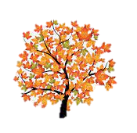
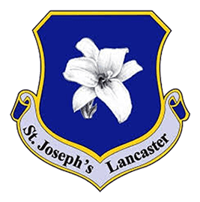
English
This half term in writing, we will be looking at discursive writing and speeches along with first person stories with morals.
In reading, we will be analysing the texts Rooftoppers and Pig Heart Boy to work on our vocabulary and comprehension skills.
For spelling, we will focus on prefixes and suffixes along with Year 6 statutory words.

Supporting your child with their learning
- Practise times tables.
- Read with your child each night.
- Provide a quiet space to complete homework.
- Help your child to tell the time using both digital and analogue clocks.

Autumn 2: Learning in Year 6
Science
We will spend this half term learning about animals, including humans, specifically focussing on the circulatory system. We will complete many exciting investigations to help support our understanding of how blood moves around our bodies.

What we are reading this half term:
- Rooftoppers
- Pig Heart Boy

Geography
In Geography this half term, we will study Earthquakes, Mountains and Volcanoes. We will use maps and atlases to locate countries and describe features studied alongside the eight points of a compass, grid references, symbols and keys.

Maths
In Maths, we will continue to develop our understanding of addition, subtraction, multiplication and division before moving on to Fractions.
Computing
In this computing unit, we will be looking at computer systems and networks as well as how to stay safe online.

PSHE
In PSHE, we will investigate how to weigh up risks, specifically looking at how drugs and alcohol can affect our bodies. We will then move on to a Human Rights unit.
Educational / Enrichment Visits
We will be visiting the cinema for the Into Film Festival and performing in our very own carol service this half term.

P.E
In PE, we will be learning specific skills associated with tennis and developing our understanding of gymnastics.

Art
In Art, we will be focussing on observational drawing, specifically looking at proportions and taking inspiration from Frida Kahlo.

R.E
This year, we will work through the Vine and Branches scheme of work. We will continue with the ‘branch’ ‘Creation and Covenant’. The vines are: The Story of Creation, Original Sin, Laudato Si, Sacrament of Baptism, The Nicene Creed and Science and Religion.
French
We will continue to learn different greetings before looking at colours and emotions.
Music
This half term we will be developing our singing skills, increasing the complexity of the songs we sing.

